**1. Demonstrate Basic File commands in Ubuntu: create folder, create file, delete folder, delete file.**

**create folder**

root@DESKTOP-623DOIP:~# mkdir AIMCA

root@DESKTOP-623DOIP:~# cd AIMCA

**create file**

root@DESKTOP-623DOIP:~/AIMCA# cat > BCA

java

dbms

C

Computer multimedia and Animation

^C

root@DESKTOP-623DOIP:~/AIMCA# cat > BBA

advertisement

marketing

hr

Accounting

income tax

^C

root@DESKTOP-623DOIP:~/AIMCA# cat BCA

java

dbms

C

Computer multimedia and Animation

**delete file**

root@DESKTOP-623DOIP:~/AIMCA# cat BBA

advertisement

marketing

hr

Accounting

income tax

root@DESKTOP-623DOIP:~/AIMCA# rm BBA

root@DESKTOP-623DOIP:~/AIMCA# ls

BCA

root@DESKTOP-623DOIP:~/AIMCA# rm BCA

root@DESKTOP-623DOIP:~/AIMCA# ls

**delete folder**

root@DESKTOP-623DOIP:~/AIMCA# cd\

>

root@DESKTOP-623DOIP:~# rmdir AIMCA

root@DESKTOP-623DOIP:~#

1. **Demonstrate any four Basic networking commands in Ubuntu.**
2. **Ifconfig**

Linux ifconfig stands for interface configurator.

Basic information displayed upon using ifconfig are:

1. IP address
2. MAC address
3. MTU(Maximum Transmission Unit)

**Output:**

This picture shows the IP address of 3 networks, Ethernet, local network, and WLAN.

**root@DESKTOP-623DOIP:~# ifconfig**

eth0: flags=4163<UP,BROADCAST,RUNNING,MULTICAST> mtu 1500

inet 172.21.171.14 netmask 255.255.240.0 broadcast 172.21.175.255

inet6 fe80::215:5dff:feec:78df prefixlen 64 scopeid 0x20<link>

ether 00:15:5d:ec:78:df txqueuelen 1000 (Ethernet)

RX packets 162 bytes 26333 (26.3 KB)

RX errors 0 dropped 0 overruns 0 frame 0

TX packets 14 bytes 1076 (1.0 KB)

TX errors 0 dropped 0 overruns 0 carrier 0 collisions 0

lo: flags=73<UP,LOOPBACK,RUNNING> mtu 65536

inet 127.0.0.1 netmask 255.0.0.0

inet6 ::1 prefixlen 128 scopeid 0x10<host>

loop txqueuelen 1000 (Local Loopback)

RX packets 0 bytes 0 (0.0 B)

RX errors 0 dropped 0 overruns 0 frame 0

TX packets 0 bytes 0 (0.0 B)

TX errors 0 dropped 0 overruns 0 carrier 0 collisions 0

1. **Hostname –I**

**Output:**

## to get your IP address in Ubuntu

**root@DESKTOP-623DOIP:~# hostname -I**

172.21.171.14

### 3. netstat

netstat command used to review each network connection and open sockets on the Linux device.  It provides connections, open sockets, routing tables information.

**root@DESKTOP-623DOIP:~# netstat**

Active Internet connections (w/o servers)

Proto Recv-Q Send-Q Local Address Foreign Address State

Active UNIX domain sockets (w/o servers)

Proto RefCnt Flags Type State I-Node Path

### 4.route

route command is used to shows or modifies the system’s routing table. Using this command, you can troubleshoot the network issue caused by a wrong entry in the system routing table. Setting a routing table is very important to make the router work correctly.

**root@DESKTOP-623DOIP:~# route**

Kernel IP routing table

Destination Gateway Genmask Flags Metric Ref Use Iface

default DESKTOP-623DOIP 0.0.0.0 UG 0 0 0 eth0

172.26.48.0 0.0.0.0 255.255.240.0 U 0 0 0 eth0

1. **How to check for a file existence in the file system using ubuntu**

**root@DESKTOP-623DOIP:~# vi bca.sh**

echo " Enter filename "

read fn

if [ -f $fn ]

then

echo "File exist "

else

echo " File does not exist "

fi

**Output:**

root@DESKTOP-623DOIP:~# bash bca.sh

Enter filename

hello.c

File exist

**4. Demonstrate the Vi Editor & its Mods in Ubuntu**

**a. Command mod**

**k ,j ,M, L,( , ), H**

**b. Insert mod**

I a A o O r R

c. ex Mode

wq, w fileName ,Searching and Replacing , Block delete commands

a. Command Mod

k : Moves the cursor up one line.

j : Moves the cursor down one line.

M : Move to middle of screen.

L : Move to bottom of screen.

( : Positions cursor to beginning of current sentence.

) : Positions cursor to beginning of next sentence.

H : Move to top of screen.

**b. Insert mod**

I : Inserts text at beginning of current line.

a : Inserts text after current cursor location.

A : Inserts text at end of current line.

o: Creates a new line for text entry below cursor location.

O : Creates a new line for text entry above cursor location.

r : Replace single character under the cursor with the next character typed.

R : Replaces text from the cursor to right.

c. ex Mode

wq : Write and quit (save and exit).

w fileName : Write to file called fileName (save as).

Searching and Replacing in (ex Mode): vi also has powerful search and replace capabilities. The formal syntax for searching is:

:s/string

Block delete commands in (x mode): need to press ESC and then commands will be followed by colon(:).

:1d delete the line 1.

:1,5d deletes the lines from 1 to 5.

**5.Demonstrate Basic networking commands in Ubuntu: ifconfig, ip, ping,traceroute,tracepath**

* 1. **Ifconfig**

Linux ifconfig stands for interface configurator.

Basic information displayed upon using ifconfig are:

* 1. IP address
  2. MAC address
  3. MTU(Maximum Transmission Unit)

**Output:**

This picture shows the IP address of 3 networks, Ethernet, local network, and WLAN.

**root@DESKTOP-623DOIP:~# ifconfig**

eth0: flags=4163<UP,BROADCAST,RUNNING,MULTICAST> mtu 1500

inet 172.21.171.14 netmask 255.255.240.0 broadcast 172.21.175.255

inet6 fe80::215:5dff:feec:78df prefixlen 64 scopeid 0x20<link>

ether 00:15:5d:ec:78:df txqueuelen 1000 (Ethernet)

RX packets 162 bytes 26333 (26.3 KB)

RX errors 0 dropped 0 overruns 0 frame 0

TX packets 14 bytes 1076 (1.0 KB)

TX errors 0 dropped 0 overruns 0 carrier 0 collisions 0

lo: flags=73<UP,LOOPBACK,RUNNING> mtu 65536

inet 127.0.0.1 netmask 255.0.0.0

inet6 ::1 prefixlen 128 scopeid 0x10<host>

loop txqueuelen 1000 (Local Loopback)

RX packets 0 bytes 0 (0.0 B)

RX errors 0 dropped 0 overruns 0 frame 0

TX packets 0 bytes 0 (0.0 B)

TX errors 0 dropped 0 overruns 0 carrier 0 collisions 0

* 1. **IP**

The **ip** command helps view and configure routing, interfaces, network devices, and tunnels. The **ip** command shows the help menu when used without any options, objects, or commands:

**root@DESKTOP-623DOIP:~# ip**

Usage: ip [ OPTIONS ] OBJECT { COMMAND | help }

ip [ -force ] -batch filename

where OBJECT := { link | address | addrlabel | route | rule | neigh | ntable |

tunnel | tuntap | maddress | mroute | mrule | monitor | xfrm |

netns | l2tp | fou | macsec | tcp\_metrics | token | netconf | ila |

vrf | sr | nexthop }

OPTIONS := { -V[ersion] | -s[tatistics] | -d[etails] | -r[esolve] |

-h[uman-readable] | -iec | -j[son] | -p[retty] |

-f[amily] { inet | inet6 | mpls | bridge | link } |

-4 | -6 | -I | -D | -M | -B | -0 |

-l[oops] { maximum-addr-flush-attempts } | -br[ief] |

-o[neline] | -t[imestamp] | -ts[hort] | -b[atch] [filename] |

-rc[vbuf] [size] | -n[etns] name | -N[umeric] | -a[ll] |

-c[olor]}

**Add the -V option to see the current version:**

The output prints the package and library version for the **ip** utility.

**root@DESKTOP-623DOIP:~# ip -V**

**ip utility, iproute2-ss200127**

### ping

The ping command  is a network utility for testing whether a host is reachable. The command sends ICMP requests to a host (a computer or server) and measures the round-trip time (RTT).

Pinging helps determine the network latency between two nodes and whether a network is reachable.

**root@DESKTOP-623DOIP:~# ping google.com**

PING google.com (142.250.193.174) 56(84) bytes of data.

64 bytes from maa05s26-in-f14.1e100.net (142.250.193.174): icmp\_seq=1 ttl=57 time=49.2 ms

64 bytes from maa05s26-in-f14.1e100.net (142.250.193.174): icmp\_seq=2 ttl=57 time=49.9 ms

64 bytes from maa05s26-in-f14.1e100.net (142.250.193.174): icmp\_seq=3 ttl=57 time=49.1 ms

64 bytes from maa05s26-in-f14.1e100.net (142.250.193.174): icmp\_seq=4 ttl=57 time=48.2 ms

64 bytes from maa05s26-in-f14.1e100.net (142.250.193.174): icmp\_seq=5 ttl=57 time=49.2 ms

^C

--- google.com ping statistics ---

6 packets transmitted, 5 received, 16.6667% packet loss, time 5008ms

rtt min/avg/max/mdev = 48.195/49.130/49.896/0.544 ms

* 1. **Traceroute**

The [traceroute command](https://phoenixnap.com/kb/how-to-run-traceroute" \t "_blank) is a networking diagnostics tool available for Linux, macOS, and Windows. The command tracks the route that packets take to reach a destination on a TCP/IP network.

Use the command to discover routing issues and bottlenecks by showing a packet's intermediate hops while traveling from source to destination.

**root@DESKTOP-623DOIP:~# traceroute google.com**

traceroute to google.com (142.250.205.238), 30 hops max, 60 byte packets

### Tracepath

The **tracepath** command is similar to the **traceroute** command. The command identifies paths and latencies from source to destination, mapping the router and network hops.

**root@DESKTOP-623DOIP:~# tracepath google.com**

1?: [LOCALHOST] pmtu 1500

1: DESKTOP-623DOIP.mshome.net 0.241ms

1: DESKTOP-623DOIP.mshome.net 0.129ms

2: 192.168.1.1 2.243ms

3:

192.168.1.1 2.932ms pmtu 1492

^C

1 DESKTOP-623DOIP.mshome.net (172.31.16.1) 0.690 ms 0.653 ms 0.641 ms

2 192.168.1.1 (192.168.1.1) 2.804 ms 2.791 ms 2.781 ms

3 \*

* 1. **Demonstrate Basic File commands in Ubuntu: create file using cat, rename same file and delete same file.**
     1. **cat**

root@DESKTOP-623DOIP:~# cat > AIMCA

BCA

BBA

kjjd

dsd

^C

root@DESKTOP-623DOIP:~# cat > AITM

CS

MECH

CIVIL

* + 1. **rename same file**

root@DESKTOP-623DOIP:~# mv AITM ACFW

root@DESKTOP-623DOIP:~# cat ACFW

CS

MECH

CIVIL

**3.delete same file**

root@DESKTOP-623DOIP:~# rm ACFW

root@DESKTOP-623DOIP:~# cat ACFW

cat: ACFW: No such file or directory

* 1. **Install Git on Ubuntu and write the each steps of installation**

Step 1. Start by updating the system package index. Launch a terminal window (Ctrl+Alt+T) and run the following command:

**sudo apt update**

Updating the package index ensures you’re working with the latest software versions.

**root@DESKTOP-623DOIP:~# sudo apt update**

**Fetched 15.3 MB in 6s (2540 kB/s)**

**Reading package lists... Done**

**Building dependency tree**

**Reading state information... Done**

1. **ckages can be upgraded. Run 'apt list --upgradable' to see them.**

Step 2. Install Git from the default Ubuntu repository by running:

**sudo apt install git**

**root@DESKTOP-623DOIP:~# sudo apt install git**

**Reading package lists... Done**

**Building dependency tree**

**Reading state information... Done**

Step 3. Verify the installation and version by running:

**git –version**

**root@DESKTOP-623DOIP:~# git --version**

**git version 2.25.1**

* 1. **Create your college website using Bootstrap components**

**STEPS :**

1. Create a new Folder in the system.

2. Add / open the folder in VScode.

3. Click on file option in VS code and create a new html file.

EX: 'filename.html'

4. Goto the browser and open "BOOTSTRAP" website.

5. Scroll down and copy css and js link and paste it to the head section of html code.

6. Add components like Navbar , img to the body section of html code.

7. Then Click on run live server.

**Output:**

**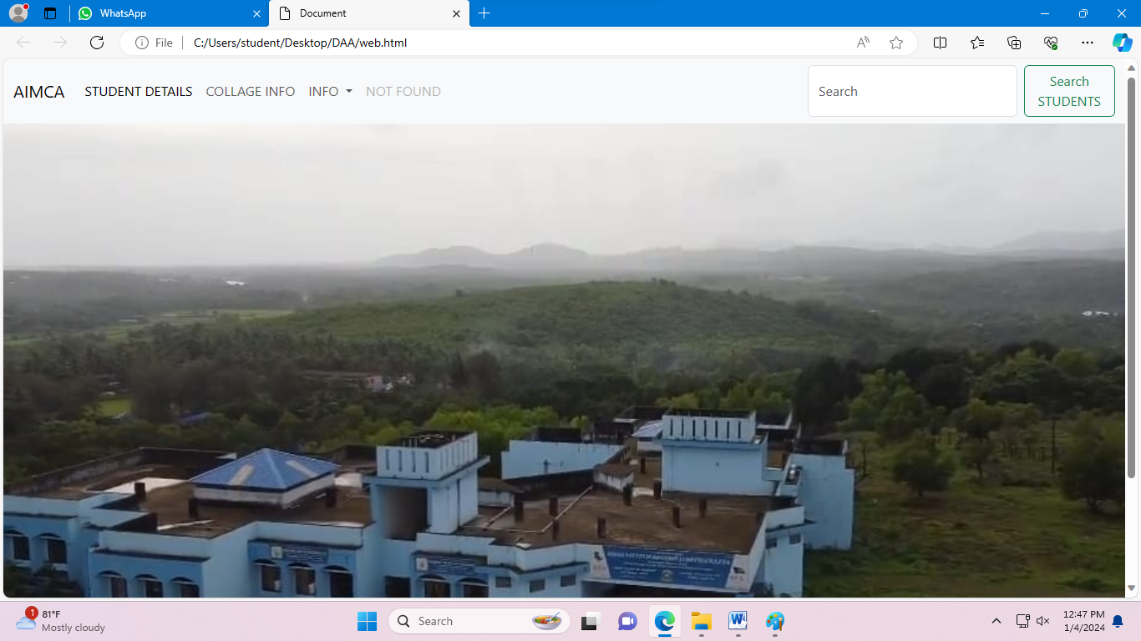**

* 1. **Write and demonstrate the steps to create Wikipedia account**

step1: Go to the Wikipedia website and click on the "Create account" button in the top- right corner of the page.

step 2:Fill out the registration form by entering your email address, username, and password. You will also need to enter a captcha to verify that you are not a robot.

step 3: Click on the "Create your account" button to complete the registration process.

step 4:After creating your account, you can create a Wikipedia page for yourself.

* 1. **Write steps and demonstrate updating Mozilla Firefox.**

**Here are the steps to update Mozilla Firefox:**

step 1: Open Mozilla Firefox and click on the menu button (three horizontal lines) in the top-right corner of the window.

step 2:From the menu, go to "Help" and then click on "About Firefox".

step 3: In the "About Firefox" window, Firefox will check for updates and display the current version number. If an update is available, it will be downloaded and installed automatically.

If no update is available, you will see a message saying "Firefox is up to date".

step 4: Click on "Restart to update Firefox" to apply the updates and restart the browser.

That's it! Mozilla Firefox will now be updated to the latest version.

* 1. **Demonstrate LibreOffice Writer.**

**To prepare an advertisement to a company with the following specifications**

**a. Attractive Frame**

**b. Design the name of company using WordArt.**

**c. Add an image**

**Steps:**

* + 1. Open Libre Office writer.
    2. Save file use File > Save As> give valid name and click Save.
    3. Click Insert > Frame>Fram Interactively.
    4. Select Frame and format the frame border, area
    5. Design the company name use insert > FontWork Enable FontWork Option and Design Company Name.
    6. Insert ClipArt use Insert > Pictures select the picture and insert.

**Output:**

Draw the output

* 1. **Create worksheet with following fields Empno, Ename, Basic Pay(BP), Travelling Allowance(TA), Dearness Allowance(DA), House Rent Allowance(HRA), Income Tax(IT), Provident Fund(PF), Net Pay(NP)**

**Given: DA= 30% of BP, HRA=20% of BP, TA=17.5% of BP, IT=15% of BP, PF=12.5% of BP**

**Steps:-**

* + 1. Open libre office Calc spreadsheet
    2. Enter the fie of Employee as given
    3. Calculate the DA, TA, HRA, IT, PF as a percentage on the basis of Basic Pay

3.1: DA=Basicpay\*30%

3.2: HRA=Basicpay\*20%

3.3: TA=Basicpay\*17.5%

3.4: IT=Basicpay\*15%

3.5: PF=Basicpay\*12.5%

* + 1. Calculate the Net Pay by using the formulae Gross Pay= DA+TA+HRA+BP Deductions=IT+PF
    2. Net Pay= Gross Pay-Deductions

**Output:**

|  |  |  |  |  |  |  |  |  |  |  |
| --- | --- | --- | --- | --- | --- | --- | --- | --- | --- | --- |
|  |  |  | Employee Salary sheet | | | | |  |  |  |
| **Emp no** | **Ename** | **Basic pay** | **TA** | **DA** | **HRA** | **GROSS SAL** | **DEDUCTION** | | **DED TOT** | **NET SALES** |
| **IT** | **PF** |
| 101 | Anil Kumar | 50000 | 8750 | 15000 | 10000 | 83750 | 7500 | 6250 | 13750 | 70000 |
| 102 | r.madhu | 40000 | 7000 | 12000 | 8000 | 67000 | 6000 | 5000 | 11000 | 56000 |
| 103 | Ravi Kiran | 60000 | 10500 | 18000 | 12000 | 100500 | 9000 | 7500 | 16500 | 84000 |
| 103 | R.Naresh | 30000 | 5250 | 9000 | 6000 | 50250 | 4500 | 3750 | 8250 | 42000 |
| 104 | Faraz | 99999 | 17499.825 | 29999.7 | 19999.8 | 167498.325 | 14999.85 | 12499.875 | 27499.725 | 139998.6 |
| 105 | Sunaina | 99999 | 17499.825 | 29999.7 | 19999.8 | 167498.325 | 14999.85 | 12499.875 | 27499.725 | 139998.6 |

* 1. **Demonstrate LibreOffice Math: edit following formula**

****

**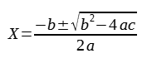**

**Code:**

d over dx [x^{n+1}over {n+1}] =x^2

n<>-1 drarrow int x^2 dx=x^{n+1 }over { n+1 }+c

n<>-1

newline

x={-b +- sqrt{b^2-4ac}}over{ 2a}

* 1. **Demonstrate LibreOffice Math: edit following formula**

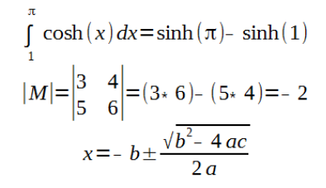

**Code:**

int from{1} to{x} cosh( x )dx=sinh( %pi )- sinh( 1 )

newline

lline M rline = left ( { matrix{3 # 4 ## 5 # 6} } right )=( 3\*6 )-( 5\*4) =-2

newline

x=- b+-sqrt{ b^2 -4ac}over{ 2a }

* 1. **Demonstrate LibreOffice Draw: Draw any one flow chart.**

Step 1: From the menu click:

View->Toolbar->Drawing

Step 2: From the left pane, click on the Flowchart tool to bring up flowchart shapes or you can select the flowchart shapes and arrow from shapes->Insert

Step 3: Click and draw them on the canvas.

Step 4: From the same left pane, click on the Connectors and select your desired arrow. Now click and draw the connector between your shapes.

Step 5: To add texts, double-click on the shape to bring up the text editor. You can now add any text you want.

Step 6: To add some text outside the shape select from Textbox or press F2 and drag and type

**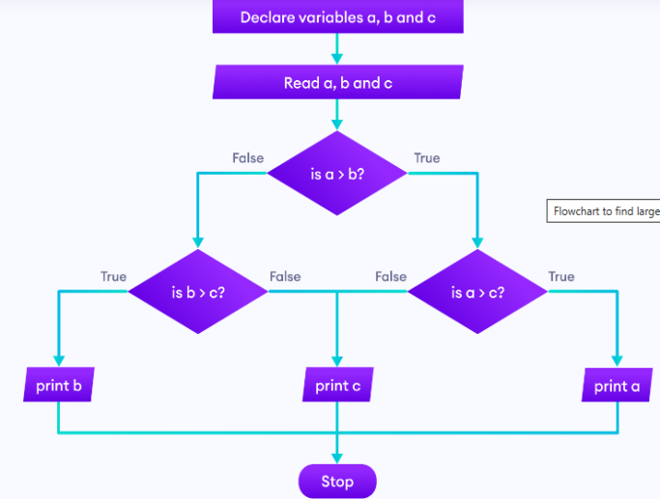**

* 1. **Demonstrate LibreOffice Impress Presentation**

**Step 1:** Open LibreOffice Impress.

**Step 2:** If the template dialog opens, select a template you would like. Otherwise, click cancel.

You will be presented with the first slide with a default design – A title and content.

**Step 3:** Modify your presentation slide as per your choice using the toolbar options, e.g. Changing font colour, background colour, adding text etc.

**Step 4:** Apply animation and transition to your slide from properties

**Step 5:** From the File menu, click **Save As**… Choose any file types you want. You can also choose the Microsoft PowerPoint file type \*.ppt or \*.pptx as well. Save the file.

**Step 6:** Run the slide by click on slide show or press F5



* 1. **Write the steps to install GNU compiler to Ubuntu**

### ****Step 1. Update Your Server****

**root@DESKTOP-623DOIP:~# sudo apt update**

### ****Step 2: Install GCC****

root@DESKTOP-623DOIP:~#sudo apt install gcc

### ****Step 3: Check Version****

root@DESKTOP-623DOIP:~# gcc –version

gcc (Ubuntu 9.4.0-1ubuntu1~20.04.1) 9.4.0

Copyright (C) 2019 Free Software Foundation, Inc.

This is free software; see the source for copying conditions. There is NO

warranty; not even for MERCHANTABILITY or FITNESS FOR A PARTICULAR PURPOSE.

### ****Step 6: Write a Sample Program****

Now that gcc compiler is installed, it is time to write a sample C program to test the compiler

root@DESKTOP-623DOIP:~# nano hello1.c

#include<stdio.h>

void main()

{

printf("Hello Ubunto\n");

}

**To compile the above program**

root@DESKTOP-623DOIP:~# gcc -o hello1 hello1.c

Then you can run the program by using

root@DESKTOP-623DOIP:~# ./hello1

Hello Ubunto